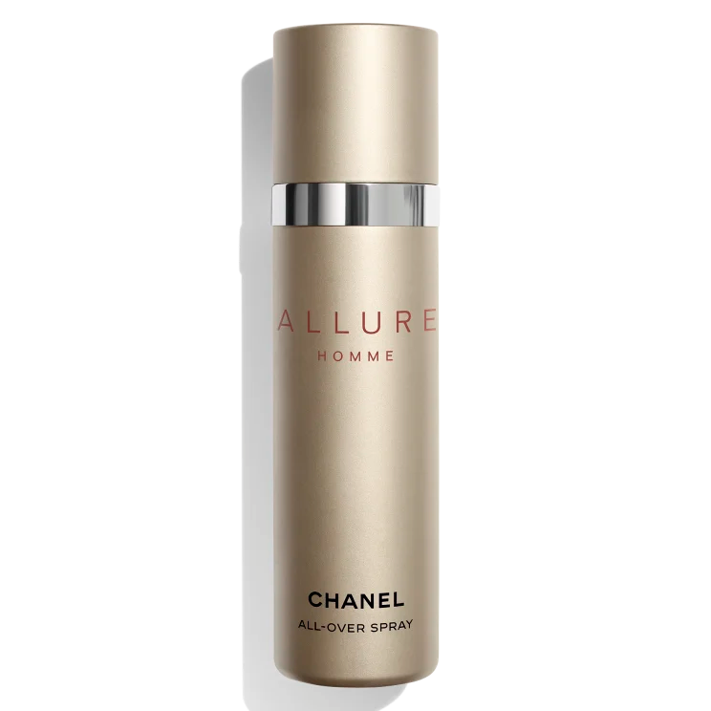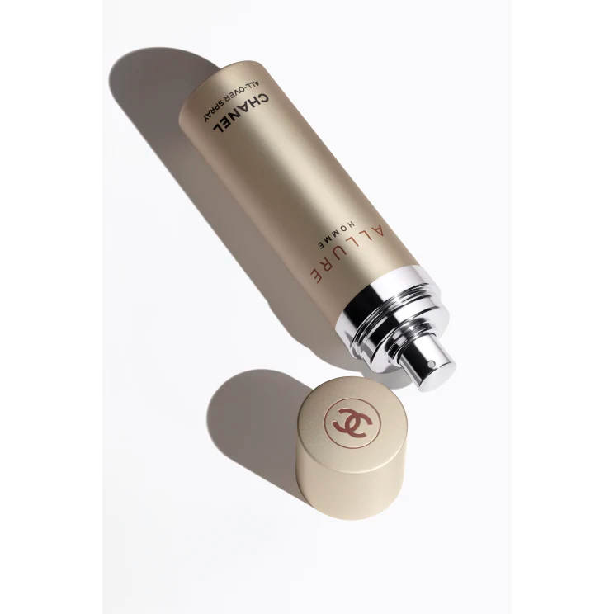

**ALLURE HOMME**

$90

Tax Included.

Spray 100 mL

IN STOCK

**Product Details**

The spicy, woody notes of ALLURE HOMME in a portable fragrance mist that can be sprayed throughout the day. Infused with Japanese green citrus extract, an exclusive ingredient developed by CHANEL, the formula helps keep skin feeling comfortable and hydrated while leaving it delicately scented.